Mobile App Testing

Use Case: Fingerprint and Passcode Verification:

The user can log in to the application using either their fingerprint once registered into the system or the user can use their designated email and password to log in to the app.

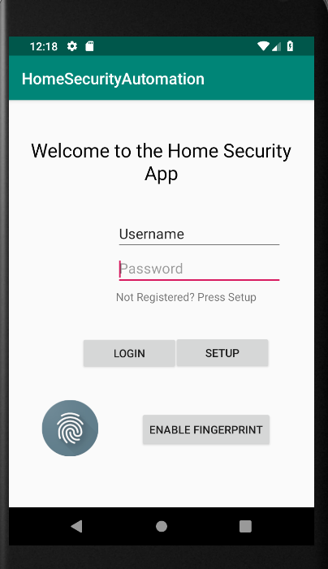 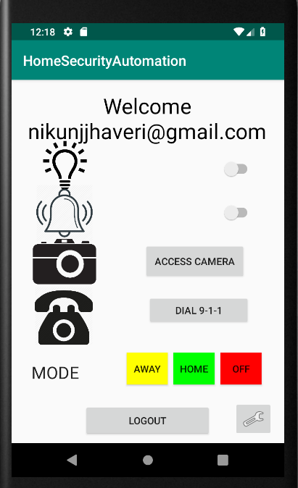

Use Case: User Log out:

The user can use the Logout button on the app’s main page as shown above to log out of the system. Logging out will return the user t the first page of the mobile app which is the login page .

Use Case: Create New User:

The admin of the app can navigate to the create new user and successfully create and add a new user to the Home Security Automation System. The newly created user has access to the app and is able to log in with the email and password that was used to set up their account.

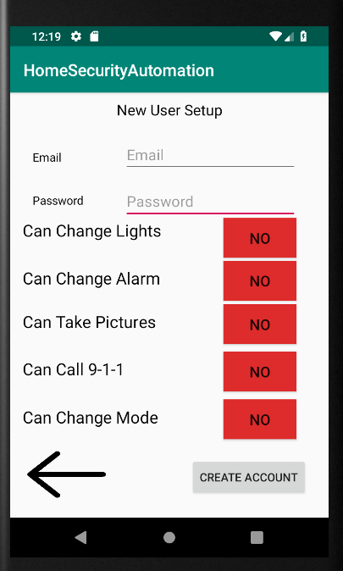 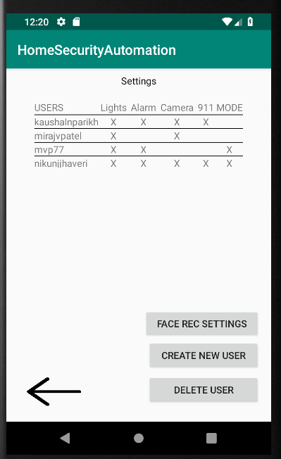

Use Case: User Profile and Creation Settings

The admin of the app and system can give and control user privileges when creating a new user. They can choose which features a user has access to on the mobile app. The admin or any other user and navigate to the settings page and view the privileges of each user in a simple and easy to understand table. The table contains a scroll bar so the viewer can see more names than initially shown.

Many of the UI pages have also been created. Transitions between the various pages work successfully and the user can view all the User Interface elements on each page. The user can interact with the different objects such as buttons, text boxes, switches and the app is able to read the user input.